**Logic Design, Fall 2013**

Verilog Lab1 – Full Adder

1. Finish FA_co.v, FA_sum.v, and FA_gatelevel.v as p.31-p33 in slides.

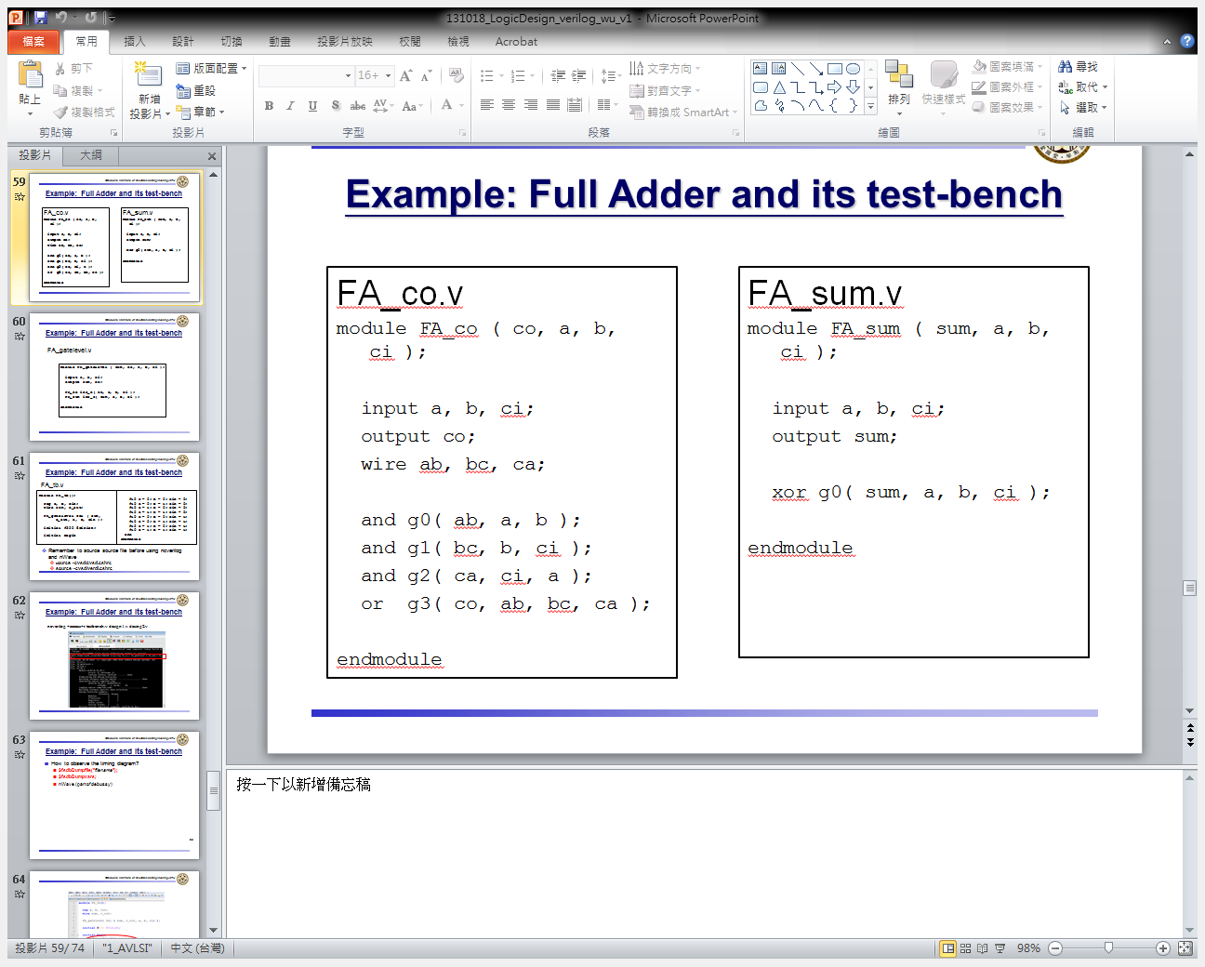

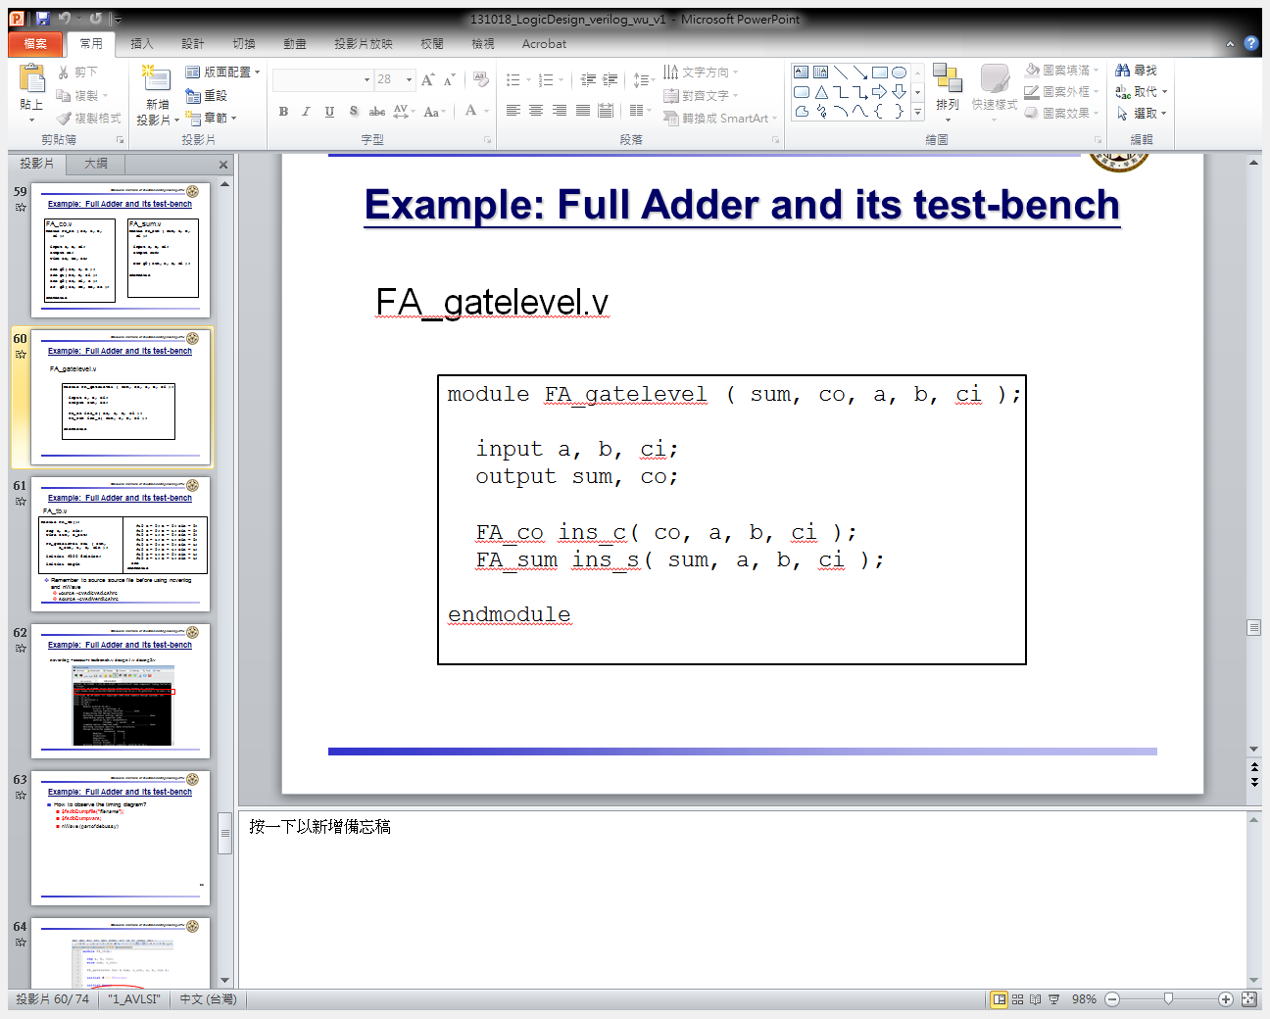

1. Finish FA_tb.v as p.64 in slides.

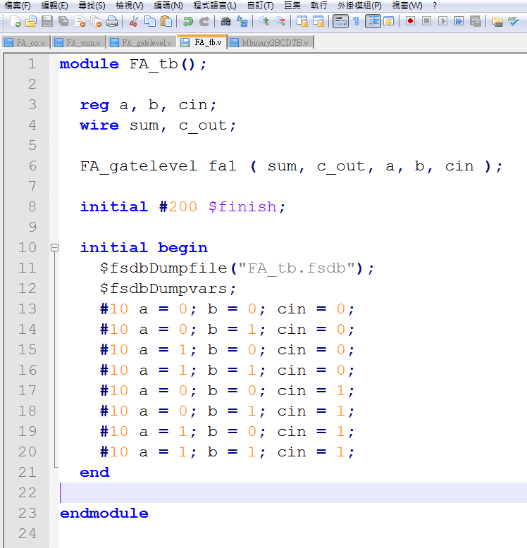

1. Source source.file before using ncverilog and nWave

* source /usr/cadence/cshrc
* source /usr/spring_soft/CIC/verdi.cshrc

1. Simulate
   * ncverilog +access+r FA_tb.v FA_gatelevel.v FA_sum.v FA_co.v
2. Check result with wave
   * nWave &